Learning Project WEEK 2 - Area you live in
Age Range: KS1
Weekly Maths Tasks (Aim to do 1 per day) | Weekly Reading Tasks (Aim to do 1 per day)
- Working on Numbots - your child will have an individual login to access this.]  - Play on The Mental Maths Train Game - focussing on number bonds to 10 and then to 20, adding and subtracting  - Choose a number between 0 - 100. Make a poster showing how many different ways can you represent this number?  - Identify 2D shapes and finish the patterns in this online game. Can any of these shapes be found around the house? How many of each shape can be found?  - Get a piece of paper and ask your child to show what they have learned in their online Maths lesson from White Rose. This could be pictures, diagrams, explanations, methods etc. They can be as creative as they want to be.  Daily Maths Lesson  The above site also daily Maths lessons which can be accessed online.  These are available for Y1 and for Y2. | - Reading a variety of books at home. Your child could share a book everyday. This can be reading a book aloud everyday or sharing a book with an adult.  - Listen to a story read: https://www.storylineonline.net/ and CBBC Bedtime stories.  - Watch Newsround and find out what is happening in the world. What did you find out? Is there anything you need help understanding? See if you can find the country the news is talking about here!  - Read the book ‘Voices in the Park’ Discuss the illustrations and why the book has been set out the way it has. You can see and hear the book here!  - Create a mask of one of the characters from ‘Voices in the Park’.  - Can your child ‘hot seat’ the character?  You pretend to be one of the characters from the story and your child ask you questions about you - the character. (You have to answer the question in character.) Then your child can be one of the characters from the story and you ask your child questions. They have to answer the question in character.
Weekly Phonics/Spellings  Tasks (Aim to do 1 per day) | Weekly Writing Tasks (Aim to do 1 per day)
- Daily phonics - Ask your child to practice their sounds and blend words. Interactive games found on link below.  - Phonics play  - Top Marks  - Spelling  - Spell the days of the week  - Spell common exception words  - Spelling City  - Sumdog spelling activities | - Ask your child to Imagine that they live in the opposite house. What would they see if they were looking into yours?  Write sentences using the suffix - ing and adjectives.  - Write your address: Discuss with your child. Do they know who delivers the post? Share a letter with them and explore the envelope from the front and back. Can they see any numbers on the front or back of the envelope? What do they mean? Who is the letter addressed to? Ask your child to write their address on the envelope. Discuss the postcode and any capital letters?  - Well known addresses: Discuss with your child any well-known addresses of book characters/famous people/ historical figures they may know? e.g. 10 Downing Street, The Post Office, Isle of Struay Katie Morag or The Jolly Postman. This Powerpoint may help. And you can find activities to do with Jolly Postman here!  - Write a letter to the Queen or another famous person you would like to write to, and post it.
Learning Project - to be done throughout the week: Where do you live?
The project this week aims to provide opportunities for your child to learn more about the area in which they live. Learning may focus on your local area, famous people, key landmarks and links to your city.

To develop knowledge of the location of significant places:
Ask your child to look at where they live. What can they see outside the window in the front of their house? At the back of their house? What could they find near them? Find a map and see if they can find Cornwall. Do they know the name of their street? Can they create a street sign with their street name?

My address: Support your child to find out your address. Can they find the number on your door? Can they write the number in digits and words? Ask them to try writing the number using crayons and paint or any other resources you might have at home.
Can they write a postcard or letter to a teacher at school? They could tell their teacher about where they live and things about their local area.

My house: Discuss with your child what their house looks like inside and outside? How many bedrooms does it have? Who has the biggest bedroom? Who has the smallest? Ask them to look outside their window and see if they can spot a house different to their own.
Can they draw their house? How many windows at the front? How many windows at the back? Do you have one door or two? In a special bag - could you (with adult support) place things that make it your home? Why would you pick those items?

Draw a picture of your street. Support your child to take a look at the street and buildings around where they live. Encourage them to think about the shape of the buildings.

Shape hunt: Take your child on a shape hunt around their house and garden. Look at the different shapes of the windows, doors, and houses. Can they name them? Are they 2D or 3D shapes?
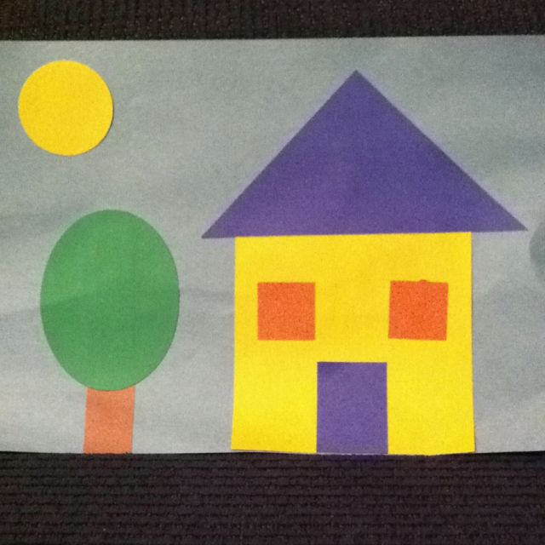
Ask them to create a picture of their house or street.

Name the shape: Place some 2D or 3D shapes (objects you can find around the house) into a bag and play the game ‘Can you name the shape?’ You will need a partner to play this game. One partner has a shape from the shape bag and they stand back to back. The partner with the shape describes it to their partner who has to try and draw it.How many do you know?

Find your house on ‘Google maps’.
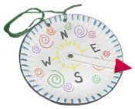
Search for your house on the street? Can you find Truro, Falmouth, Newquay, Exeter and London?

Compass: Make a compass. Do you know what the different compass points mean? Can you label the points?

Create a passport: Create an individual passport to show your own information about where you live. Discuss the use of a Passport. What is a passport? What information does it contain? What does a passport allow you to do? Can you find a real-life passport? Do you have one?

Flag: Here is the Cornish flag. What do you think the flag represents? Can you design your own flag for your town? What could you add? Why would you choose the different pictures on it?

Design a cottage - Compare how a cottage is different to your house – or if you live in a cottage, why a flat is different to a cottage. Can you make a model of your house and a cottage?

Create a song about ‘Where you live’ - Can you add your address in your song?
Can you find the UK on the map? Can you name the countries? Why do you think the Countries begin with a capital letter? This song may help.
Additional learning resources parents may wish to engage with
Classroom Secrets Learning Packs - These packs are split into different year groups and include activities linked to reading, writing, maths and practical ideas you can do around the home.
Twinkl - to access these resources click on the link and sign up using your own email address and creating your own password. Use the offer code UKTWINKLHELPS.

David Walliams FREE audio story daily
https://bit.ly/AudioElevenses

#TheLearningProjects

